

What is STEAM?
- Science
- Technology
- Engineering
- Arts
- Maths

STEAM is a holistic approach to learning the encourages children to explore, experiment, create and problem solve through their play experiences. Rather than having rigid lessons looking at each area separately, STEAM allows children to explore through fun and engaging activities.
By using this holistic approach, it equips children with the skills they need in later life to draw upon multiple aspects of learning to complete challenges and achieve their goals and aspirations.

Why is STEAM important?

STEAM helps children to develop a huge variety of skills including; curiosity, confidence, critical thinking skills and problem solving, communication, teamwork and collaborative play, creativity and resilience as well as early literacy and numeracy skills through meaningful play experiences. These skills can all enable the children to become the next designers, innovators, creators, inventors and engineers; as well as providing them with crucial skills to help them through their journey in education and beyond. STEAM complements and supports the seven areas of learning as well as the Characteristic of Effective Learning set out in the EYFS.
The children throughout the nursery will benefit from carrying out these high quality activities and interactions in a small group ensuring everyone has the opportunity to participate and be heard.
We will have a slow pedagogical approach, allowing the children the time they need to get fully emerged in an activity, without being rushed to finish or move on to another activity or area until they are ready to do so.

Our aims at Sunrise Nursery

At Sunrise we believe that all children are naturally curious and capable of becoming an active learner through enriched environments and meaningful play activities. We aim to:
- Provide high quality STEAM activities that are child-led, supported by the adults;
- Support communication, critical thinking and collaboration through shared exploration;
- Develop resilience through experimentation, risk taking and trying again if something does not go to plan;
- Promote curiosity, creativity, confidence and joy through meaningful play experiences;
- Provide open-ended resources which allow the children to explore and experiment using their own creative thinking processes – these include natural materials, loose parts, construction and engineering resources, creative arts materials, investigation stations and access to outdoor exploration opportunities.

About Me:
My name is Bryony and my journey in the world of Early Years began with Sunrise back in 2013. I started working within the Preschool room and found a passion for expanding children’s learning and play activities through simple interactions and quality play experiences. I completed my NVQ Level 3 with the support and guidance of Sunrise.
I then started my Foundation Degree in Early Childhood Studies in 2017, graduating from that in 2019, just after having my first child. I then had my second child in 2022, both of which went through Sunrise from the baby room all the way to Preschool – learning, developing and thriving in quality provision set out by the wonderful staff in all the rooms.
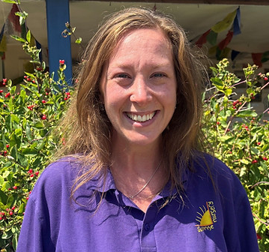

I later went on to graduate from the University of Doncaster with a BA (Hons) in Early Childhood Education. Following from this I worked towards my Early Years Teacher Status to become a qualified Early Years Teacher. Throughout my own learning journey, I discovered a passion for all aspects of STEAM as well as phonological awareness in the early years.

Babies
Within the baby room our STEAM focus will be on sensory exploration. The babies will be able to get involved in body painting, using their bodies to explore the paint and make marks with their hands, feet or by using appropriate tools. I will also be introducing them to messy tactile trays which will give them opportunity to explore sensory with their whole bodies. The babies will have access to a new sensory area full of exciting textures, resources and imagery such as cosy cushions, lights, hard, squishy or bobbly resources which they can discover with some independence. The children will explore light and shadows in the dark den. I will also support the staff in their everyday activities with the babies, developing their engineering skills with activities such as such as building with age appropriate building blocks and stacking towers which, inevitably, the children will find joy in knocking back down! We will also explore maths by shape and size sorting through inset puzzles and nesting cups. This allows the babies opportunity to safely explore resources, testing ideas and persisting after challenges, as well as expressing themselves freely and creatively. We will introduce the babies to the first aspects of phonological awareness through music making, rhyme, rhythm and dance – playing all the babies’ favourite songs to move to and singing their favourite songs with them, repeating familiar rhymes and exploring the sounds of different objects and instruments.

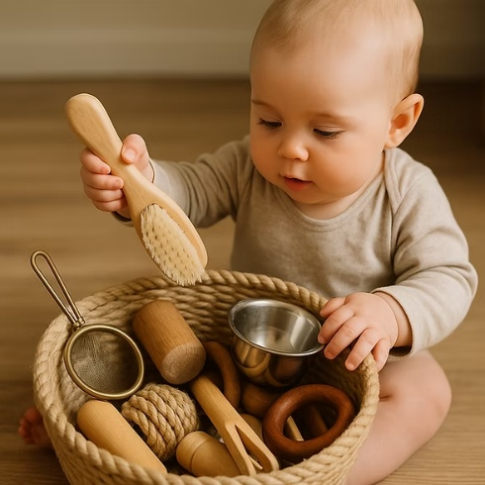

Baby Toddlers
For babies (roughly 0–2 years), STEAM (Science, Technology, Engineering, Arts, and Mathematics) is best promoted through sensory exploration, play, movement, and responsive interactions rather than formal teaching. Activities should be safe, open-ended, and encourage curiosity. We will observe cause and effect through sensory exploration and create sensory bottles to build on their own curiosity. The baby toddlers will have access to our dark den, giving them the opportunity to explore with torches, light and shadows as well as safe and age-appropriate loose parts play. The baby toddlers will be able to build on their phonological awareness by having access to the story spoons, giving them the lead in what stories or songs they want to listen and dance to. We will explore lots of songs, rhymes and favourite stories to build up that rich language bank and reinforcing their strong foundations they are already building within the nursery. The baby toddlers will have access to light up toys, enabling them to experiment with pressing buttons and seeing the cause and effect of these actions. They will have access to a large variety of tools to make changes and manipulate sensory materials; this helps build their fine motor skills, as well as engaging in valuable STEAM play. We will build sensory exploring dens that the children can crawl into, on top of and under, navigating their way around in a calm and secure environment, at their own pace. This will allow the children to build on their curiosity and problem-solving skills. We will go on nature walks on the Millennium Green, taking on a slow pedagogical approach, providing the baby toddlers with a slow moving pace for them to take in the sights, sounds, textures and smells around them. This will also allow the children opportunity to create their own treasure baskets from natural resources in the environment.

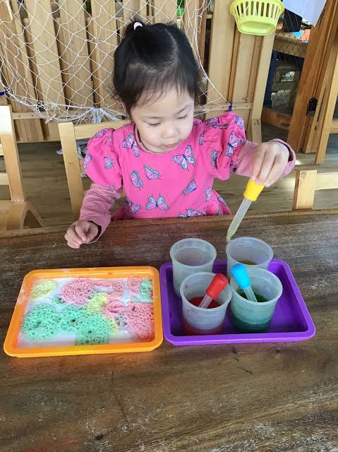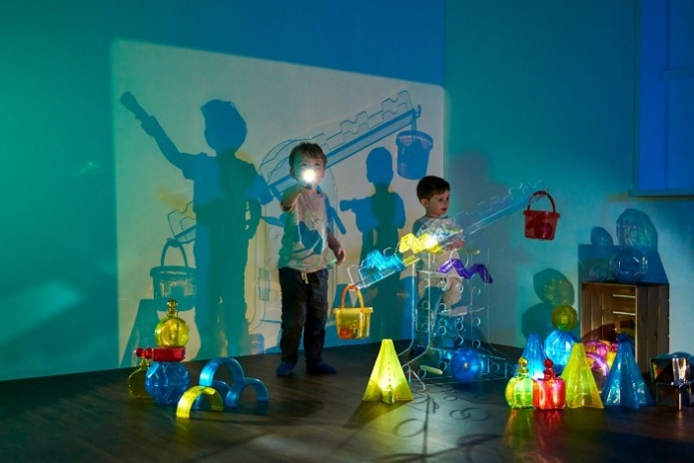

Toddlers
The toddler children will have many opportunities to explore colours and colour mixing. We will use various resources to be able to predict and observe colour changes such as using playdough the children have made or using pipettes in water to experiment with colour changes as well as using paint and various tools to mix colours in their own creative way. We will design and create our own music makers using recycled materials and we will use these homemade instruments to develop our phonological awareness further – listening and trying to identify different sounds. The children will also get to play with light and shadows in our dark den and explore shadows in the environment on sunny days or in the darker evenings with the torches.
We will use the Millennium Green to go on listening walks and colour hunts. The children will take part in Interactive Storytelling and Mindful Eating both of which we will use all our senses during focused activities, adding additional elements of exploration and really encouraging the children to think on a deeper level. E.g. Handa’s surprise – including all the fruits that Handa collects on her walk, giving the children opportunity to smell, touch and taste if they want to.
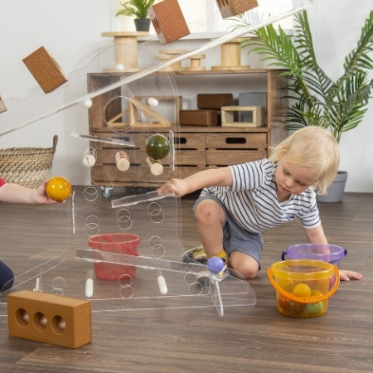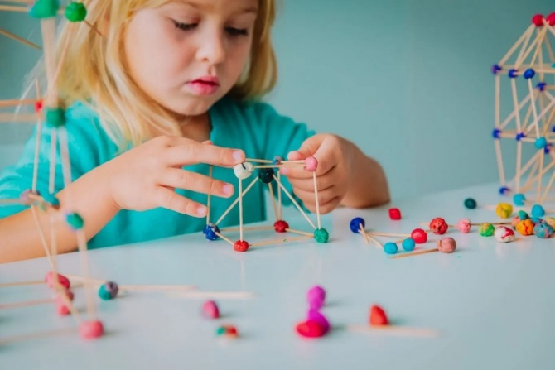

Lower Preschool
The children from Lower Preschool will really benefit from activities where we will predict the outcome of a certain experiment. The children will be able to take part in baking, creating the dough or batter by carefully measuring the ingredients and combining them with various tools, engaging in both science, technology and maths aspects of STEAM. We will vary our cooking times to see the different effects of too long/not enough time in the oven, discussing what we think might happen and observing what does actually happen – discussing our predictions afterwards. The children will also have the opportunity to observe the lifecycle of a pumpkin seed, planting their seeds, discussing what they need to grow and thrive and caring for them throughout the year. This will also allow the children to explore the arts as they will be able to design and create their own pumpkin art around Halloween, carving the pumpkins in a child-led, adult-supported activity! There will be opportunity for huge junk modelling, using boxes and materials of all shapes and sizes, incorporating technology, engineering, arts and maths in one hugely valuable play experience. This will give the children opportunity to work together, problem solve and develop resilience when things may not go to plan. Will they create rockets to visit the stars we’ve been watching? Or a tractor to go to the Pumpkin farm? There are endless possibilities!

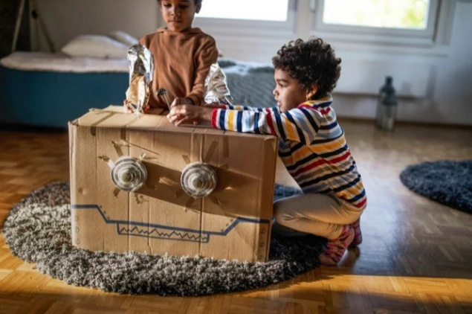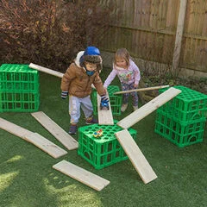
Upper Preschool
The Upper Preschool children will get to immerse themselves in some mindful meditation, focusing on breathing and encouraging the children to be present in the current moment. This will allow the children an opportunity to slow down their busy minds and take some time to re-centre their thoughts and feelings and regulate their emotions. We will partner this technique with Forest Bathing, taking out mindful meditation into the forest on the Millennium Green and bathing in the sights, sounds, smells and feelings of the forest around us. The children will get the opportunity to stargaze in the darker evenings, thinking about what we can see and how it makes us feel. We will discuss the stars, moon and sun and will keep our fingers crossed to see some satellites or even shooting stars! We will grow sunflowers to see the life cycle of the seed, creating our living bird feeder for the Autumn months. The children will get to explore all aspects of our STEAM garden where they can use science, maths and engineering skills in the mud kitchen, water area, construction site and sand pit – combining each area of play to enhance the children’s learning, problem solving and critical thinking experiences. We will further build on the children’s phonological awareness by playing sound games, singing, rhyming and reading our favourite stories as an interactive journey where the children will be active participants in acting out each part of familiar favourites. The children will also have a STEAM focused forest activity where they may roast marshmallows or construct with natural loose parts, creating small homes for wildlife or larger den building for the children to play in.

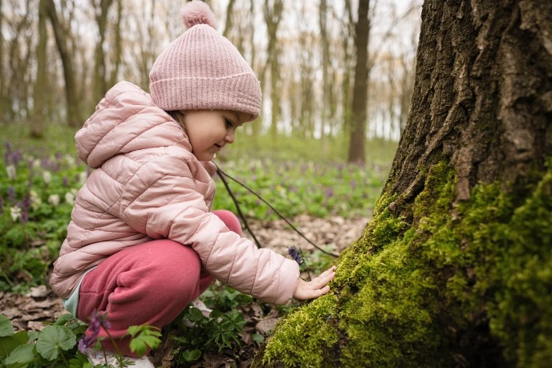

How my role will impact your little one
My role will have a positive impact on your children by creating engaging opportunities for them to explore all aspects on STEAM in a calm environment and small group sessions. We will also implement a slow pedagogical approach ensuring the children have time to explore at their own pace, immersing themselves into activities as much as they would like to. I will support the staff in the rooms to plan exciting, hands-on experiences to further develop and deepen the knowledge the children gain in the STEAM sessions. The children will have a focused opportunity to develop resilience, critical thinking, curiosity and creativity, building strong foundations for skills they will need throughout their educational journey and beyond. I will continually evaluate and enhance our STEAM provision to create a stimulating environment to enable children to reach their full potential and embed a lifelong love of learning.

